Tebong Roland

[DSC640-T302 Data Presentation & Visualization (2241-1)](https://cyberactive.bellevue.edu/webapps/blackboard/execute/courseMain?course_id=_520868_1)

[4.3 Project Task 3: Blog Post](https://cyberactive.bellevue.edu/webapps/assignment/uploadAssignment?content_id=_14812840_1&course_id=_520868_1&group_id=&mode=view)

**Unveiling the Reality of Air Travel Safety in 2021**

In recent times, the media has been awash with concerning reports regarding the safety of air travel. It's only natural to have questions and concerns, given the unprecedented challenges our world has faced. As part of our unwavering commitment to transparency, I am here to share the unvarnished truth about air travel safety in 2021.

**The Hard Numbers Speak Louder Than Words**

Let's start by looking at the hard data. In 2021, there were 29 reported aviation accidents, leading to 279 unfortunate fatalities worldwide. These are not just numbers; they represent lives and families impacted by these incidents. However, to gain a comprehensive perspective, we must compare these statistics with another mode of transportation: road travel.

In the same year, road accidents numbered a staggering 16,210,000, resulting in countless injuries and fatalities. The contrast is stark, reaffirming that air travel remains one of the safest modes of transportation.

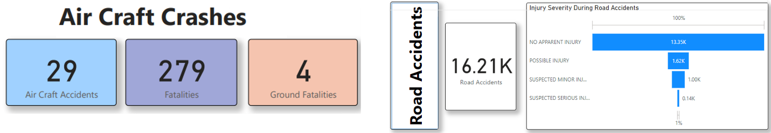

**Beyond the Numbers: A Global Perspective**

Geographically, aviation accidents are not centered around a single location. They are dispersed across the globe, with Russia and Indonesia showing higher incident rates. This distribution underscores the need for a comprehensive global approach to safety measures rather than localized solutions.

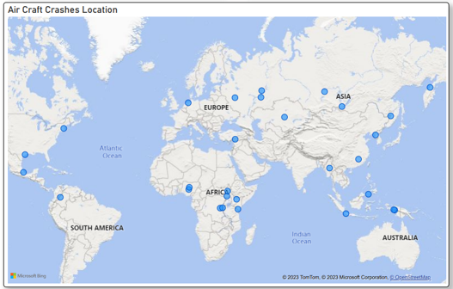

**The Diversity of Accident Categories**

Aviation accidents encompass a wide range of categories, including mechanical issues, weather-related incidents, and more. This diversity challenges us to adopt a holistic approach to safety management, addressing various factors simultaneously.

**Ethical Communication: Our Guiding Principle**

Throughout our analysis and presentation to the executive committee, ethical communication has been our guiding principle. We understand the importance of presenting accurate, transparent, and context-rich information. The responsibility of sharing this data with shareholders and the public is not taken lightly.

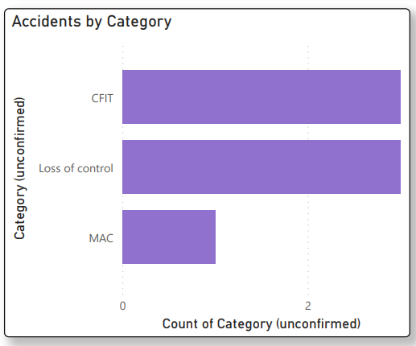

**Our Commitment to Safety and Responsibility**

As we move forward, our commitment to proactive risk management remains unwavering. Predicting and mitigating future risks is central to our safety strategy. We pledge to maintain open dialogues with our shareholders, ensuring they receive reliable data and insights.

In conclusion, the data and insights presented here are a testament to the safety of air travel in 2021. We're prepared to navigate the media landscape with facts and transparency. Our airline stands as a beacon of safety and responsibility, committed to ensuring the well-being of our passengers.

Sources:

Aviation Safety Network Flight Safety Foundation

Crash Stats & Reports NHTSA

Statistics Bureau of Aircraft Accident Archives